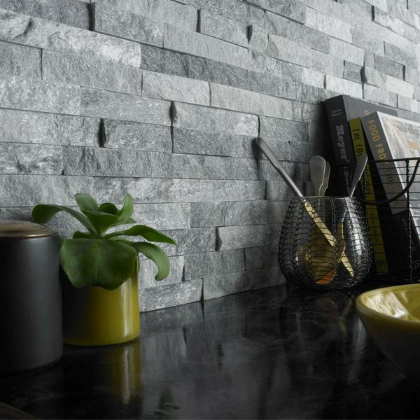**Crystal Arctic Grey:**

## **Product Description**

The luxurious properties of this natural grey quartzite mosaic tile are heightened with an undulating surface design and the tiny, crystalised particles shimmer in the light creating a lavish, charismatic wall display. Neutral in colour these natural split face tiles fit perfectly with the latest architectural and lifestyle trends - allowing you to keep at the forefront of interior design and make a long term investment for your home.

> Made by hand

> Sparkling, glittery appearance

> Natural slate

> Characterful textured surface

To help keep these tiles nice and clean, we suggest using [LTP G](https://www.wallsandfloors.co.uk/catrangetiles/tile-cleaning/ltp-cleaning-tile-protecting-tiles/ltp-grimex-cleaner-tiles/17687/)[rout Stain Remover](https://www.wallsandfloors.co.uk/catrangetiles/tile-cleaning/ltp-cleaning-tile-protecting-tiles/ltp-grout-stain-remover-cleaner-tiles/17688/). Natural stone tends to be slightly porous, so we recommend sealing your fantastic new tiles with either [LTP](https://www.wallsandfloors.co.uk/catrangetiles/tile-preparation/ltp-cleaning-tile-protecting-tiles/ltp-colour-intensifier-1ltr/17677/)[Grout and Tile Protector](https://www.wallsandfloors.co.uk/catrangetiles/tile-preparation/ltp-cleaning-tile-protecting-tiles/ltp-grout-and-tile-protector-aerosol/17680/) or [LTP Mattstone Sealer](https://www.wallsandfloors.co.uk/catrangetiles/tile-preparation/ltp-cleaning-tile-protecting-tiles/ltp-mattstone-1-ltr-tiles/17665/). To keep your tiles looking fresh and new, apply [LTP Waxwash Maintenance](https://www.wallsandfloors.co.uk/catrangetiles/tile-cleaning/ltp-cleaning-tile-protecting-tiles/ltp-waxwash-maintenance-tiles/17689/).

Due to the nature of these tiles, we do not recommend them for use in shower areas or areas that receive direct water to the surface. The manufacturing process of these tiles can leave very small joints that are difficult to completely seal.

## **Product Info**

* Product ID: 37274
* Tiles Per SQM: 22.222222222222
* Sale by: Per SQM
* Size150x300x12mm
* Weight: 1.33 KG
* Material Type: Quartzite
* Finish: Matt
* Colour: Grey
* Suitability: Walls
* Grade: No
* Rectified Edge: No
* Underfloor Heating: No
* Thickness (mm): 12